

**UNIVERSITI MALAYSIA TERENGGANU**

**CSM3023 – WEB PROGRAMMING 2**

**BACHELOR OF COMPUTER SCIENCE (MOBILE COMPUTING) WITH HONORS**

**LAB 3 – JSP: Scriplet, Page Directive & Include Directive**

**SEMESTER II 2023/2024**

**Prepared for:**

DR MOHAMAD NOR BIN HASSAN

**Prepared by:**

MUHAMMAD ARIF HAIKAL BIN SALLEHUDDIN

(S66355)

Link Github :

**Task 1: Passing Data from Main JSP’s Page to Other JSP’s Page**

Code :

memberRegister.jsp

|  |
| --- |
| <%--  Document : memberRegister  Created on : 17 Apr 2024, 2:38:20 pm  Author : ARIF HAIKAL  --%>  <%@page contentType="text/html" pageEncoding="UTF-8"%>  <!DOCTYPE html>  <html>  <head>  <meta http-equiv="Content-Type" content="text/html; charset=UTF-8">  <title>Lab 3 - Task 1</title>  </head>  <body>  <h1>Passing data from main JSP's page to other JSP's page</h1>  <form id="memberFrm" action="memberProcessing.jsp" method="post" onsubmit="return checkICNo()">  <fieldset>  <legend>Member Registration</legend>  <label for="invoiceno">Ic No *</label>  <input type="text" id="icno" name="my_icno" size="15" placeholder="E.g. 921012101245"><br/>    <label for="name">Name</label>  <input type="text" id="name" name="my_name" size="45" placeholder="Key-in your name"></br>    <p><input type="submit" id="btnSubmit" value="Submit"/>  <input type="reset" id="btnCancel" value="Cancel"/>  </p>  </fieldset>  </form>  </body>  <footer>&copy2024-ARIF HAIKAL</footer>  </html> |

memberProcessing.jsp

|  |
| --- |
| <%--  Document : memberProcessing  Created on : 17 Apr 2024, 2:59:47 pm  Author : ARIF HAIKAL  --%>  <%@page contentType="text/html" pageEncoding="UTF-8"%>  <!DOCTYPE html>  <html>  <head>  <meta http-equiv="Content-Type" content="text/html; charset=UTF-8">  <title>Lab 3 - Task 1</title>  </head>  <body>  <h1>Passing data from main JSP's page to other JSP's page</h1>  <form id="memberFrm" action="memberProcessing.jsp" method="post" onsubmit="return checkICNo()">  <fieldset>  <%  String myIC = null;  String myName = null;    myIC = request.getParameter("my_icno");  myName = request.getParameter("my_name");  %>    <p>Thank you for registering in this event..!</p>  <p>This is your details:</p>  <p>IC No : <%=myIC%></p>  <p>Name : <%=myName%></p>  </fieldset>  </form>  </body>  <footer>&copy2024-ARIF HAIKAL</footer>  </html> |

Output :

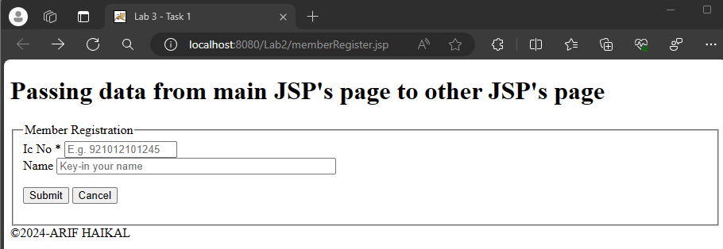

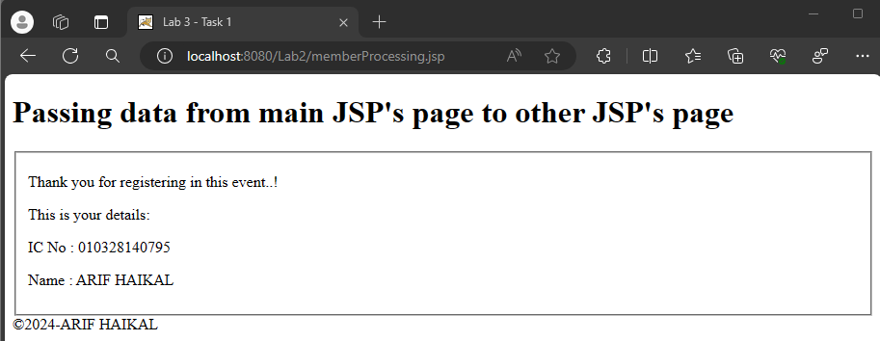

**Reflection**

1. How do you want to submit specific information from one form to next form?

Using the "action" element in the form tag and sending the data using HTTP request methods like GET or POST, you may use JSP to transmit specific data from one form to the next.

1. What happened if the field name you specify in

request.getParameter(“field_name”) in second page is different from the field

name you defined in first page?

Assuming that the request's field name was given.The parameter value won't be received correctly as getParameter("field_name") on the second page differs from the field name specified on the first page. Alternatively, an empty string or null will be returned. For data to be retrieved and processed correctly, field names must be consistent across pages.

**Task 2: Using Mathematics Operations in JSP**

Code :

calculator.jsp

|  |
| --- |
| <%--  Document : Calculator  Created on : 17 Apr 2024, 3:23:12 pm  Author : ARIF HAIKAL  --%>  <%@page contentType="text/html" pageEncoding="UTF-8"%>  <!DOCTYPE html>  <html>  <head>  <meta http-equiv="Content-Type" content="text/html; charset=UTF-8">  <title>Calculator</title>  </head>  <body bgcolor="#a00FFF" text="gold">    <%  String num1 = "0", num2 = "0";  int result = 0;  String op = "+";    char opchar = op.charAt(0);  if (request.getParameter("op") != null) {  op = request.getParameter ("op");  opchar = op.charAt(0);    num1 = request.getParameter("operand1");  num2 = request.getParameter("operand2");    switch(opchar) {  case '0': result = Integer.parseInt(num1) + Integer.parseInt(num2);  break;  case '1': result = Integer.parseInt(num1) - Integer.parseInt(num2);  break;  case '2': result = Integer.parseInt(num1) * Integer.parseInt(num2);  break;  case '3': result = Integer.parseInt(num1) / Integer.parseInt(num2);  break;  case '4': result = Integer.parseInt(num1) % Integer.parseInt(num2);  break;  }  }  %>    <center>  <h2>Basic calculator program in jsp</h2>  <form method="get" name="f1">  <input type="text" size="20" name="operand1" value = <%= num1 %> />  <select name = op size = 1>  <option value = "0" >+</option>  <option value = "1" >-</option>  <option value = "2" >*</option>  <option value = "3" >/</option>  <option value = "4" >%</option>    <input type="text" size="20" name="operand2" value = <%= num2 %> />  <p>  <input type= submit value = Calculate />    Result = <%= result + "" %>    </form>  </body>  </html> |

Output :

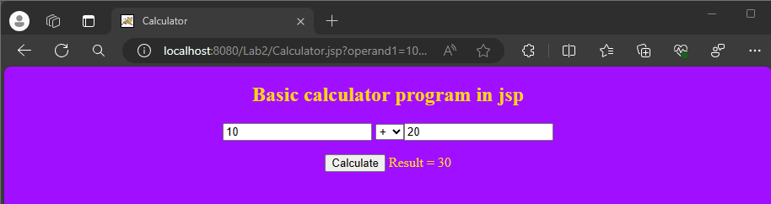

**Reflection**

1. How do you want to submit specific information from one form to next

form?

Using the "action" element in the form tag and sending the data using HTTP request methods like GET or POST, you may use JSP to transmit specific data from one form to the next.

1. What happened if the field name you specify in

*request.getParameter(“field_name”)* in second page is different from

the field name you defined in first page?

Assuming that the request's field name was given.The parameter value won't be received correctly as getParameter("field_name") on the second page differs from the field name specified on the first page. Alternatively, an empty string or null will be returned. For data to be retrieved and processed correctly, field names must be consistent across pages.

**Task 4: Perform Calculation of Car Loan**

Code :

calculateCarLoan.jsp

|  |
| --- |
| <!DOCTYPE html>  <html lang="en">  <head>  <meta charset="UTF-8">  <meta name="viewport" content="width=device-width, initial-scale=1.0">  <title>Car Loan Calculator</title>  </head>  <body>  <h1>Perform Car Loan Calculation</h1>  <form action="processCalculateCarLoan.jsp" method="post">  <fieldset>  <legend>Loan Calculation</legend>  <label for="loanAmount">Loan Amount: </label>  <input type="number" id="loan-amount" name="loanAmount" required>  <br> <br>  <label for="loan-period">Period: </label>  <select id="loan-period" name="loanPeriod" required>  <option value="3">3 year</option>  <option value="4">4 years</option>  <option value="5">5 years</option>  <option value="7">7 years</option>  </select><br><br>  <input type="submit" id="btnSubmit" value="Submit"/>  <input type="reset" id="btnCancel" value="Cancel"/>  </fieldset>  </form>  </body>  <footer>&copy2024-ARIF HAIKAL</footer>  </html> |

processCalculateCarLoan.jsp

|  |
| --- |
| <%--  Document : processCalculateCarLoan  Created on : 19 Apr 2024, 9:55:01 pm  Author : ARIF HAIKAL  --%>  <%@page contentType="text/html" pageEncoding="UTF-8"%>  <!DOCTYPE html>  <html lang="en">  <head>  <meta charset="UTF-8">  <meta name="viewport" content="width=device-width, initial-scale=1.0">  <title>Car Loan Result</title>  </head>  <body>  <h1>Perform Car Loan Calculation</h1>  <%  // Retrieve parameters from the request  String loanAmountStr = request.getParameter("loanAmount");  String loanPeriodStr = request.getParameter("loanPeriod");    // Parse parameters to integers  int loanAmount = Integer.parseInt(loanAmountStr);  int loanPeriod = Integer.parseInt(loanPeriodStr);    // Calculate annual interest rate based on loan period  double annualInterestRate;  if (loanPeriod < 5) {  annualInterestRate = 0.028; // 2.8% annual interest rate for loan period less than 5 years  } else {  annualInterestRate = 0.045; // 4.5% annual interest rate for loan period 5 years or more  }    double monthlyInterestRate = annualInterestRate / 12;  int totalMonths = loanPeriod * 12;    // Calculate monthly payment  double monthlyPayment = (loanAmount * monthlyInterestRate) / (1 - Math.pow(1 + monthlyInterestRate, -totalMonths));    // Calculate total loan with interest  double totalLoan = monthlyPayment * totalMonths;    // Display result  %>    <fieldset>  <h1 style="color: blue;">Details of car loan:</h1>  <p>Loan Request: RM <%= loanAmount %></p>  <p>Period of payment: <%= loanPeriod %> years</p>  <p>Total Loan (+interest): RM <%= String.format("%.2f", totalLoan) %></p>  </fieldset>  </body>  <footer>&copy2024-ARIF HAIKAL</footer>  </html> |

Ouput :

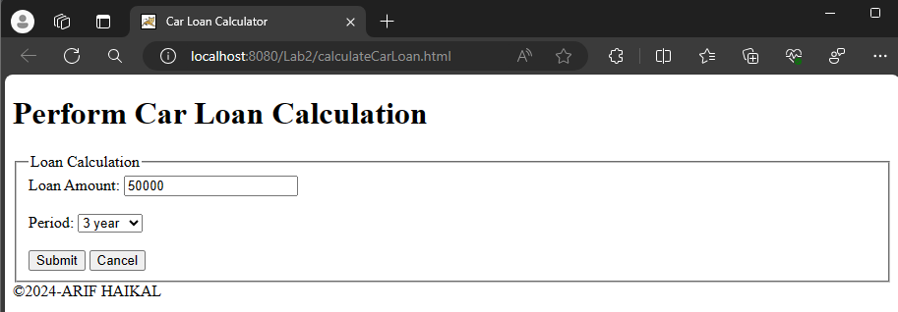

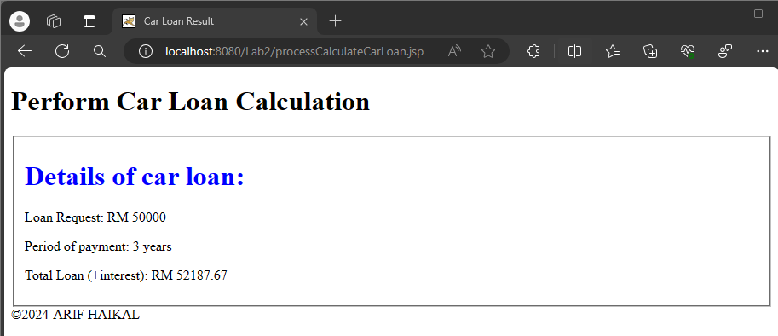

**Reflection**

1. How you want to retrieve data from previous page?

In JSP, you can utilise the request object to get data from the previous page.

1. Where the construction of logic occur for calculating Total Loan ( + interest) ?

The Java code integrated in the JSP file is usually where the logic for determining the total loan amount (interest included) is constructed in a JSP (JavaServer Pages) application. The Java code segment implements this logic by doing computations based on the loan amount, interest rate, and any other pertinent information.

**Task 5: Using JSP Page Directive to Call Java API**

Code :

ArrayList.jsp

|  |
| --- |
| <%--  Document : ArrayList  Created on : 22 Apr 2024, 10:46:17 pm  Author : ARIF HAIKAL  --%>  <%@page contentType="text/html" pageEncoding="UTF-8"%>  <%@page import="java.util.ArrayList"%>  <!DOCTYPE html>  <html>  <head>  <meta http-equiv="Content-Type" content="text/html; charset=UTF-8">  <title>Use Java ArrayList</title>  </head>  <body>  <h1>Use JSP Page Directive</h1>  <%  ArrayList<String> studentList = new ArrayList<String>();    studentList.add(0, "Mohamad Azam");  studentList.add(1, "Peter Chong");  studentList.add(2, "Rahimah Mansor");  studentList.add(3, "Sri Devi");  studentList.add(4, "Ng Hue Ween");  studentList.add(5, "S. Nagarajan");    out.println("<p><font color=\"blue\">The number of records in ArrayList are " + studentList.size() + "</font></p>");    for (int i=0; i< studentList.size(); i++) {  out.println("<p><font color=\"blue\">Record " + (i+1) + " is " + studentList.get(i) + "</font></p>");  }  %>  </body>  <footer>&copy2024-ARIF HAIKAL</footer>  </html> |

Output :

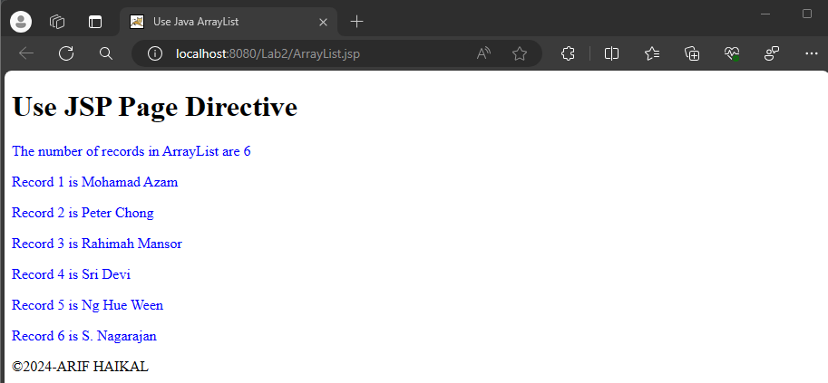

**Reflection**

1. What you have learnt from this exercise?

I learnt about utilize java ArrayList in JSP.

1. Write a sample syntax how you want to use java *Math* object in JSP?

<%@page import="java.lang.Math"%>

3) List and write a sample syntax for THREE (3) of JSP page directive.

<%@page import="java.util.ArrayList"%>

<%@page contentType="text/html" pageEncoding="UTF-8"%>

<%@page language="java" %>

**Task 6: Use JSP Include directive for JSP Page**

Code :

mainPage.jsp

|  |
| --- |
| <%--  Document : mainPage  Created on : 23 Apr 2024, 12:39:12 am  Author : ARIF HAIKAL  --%>  <%@page contentType="text/html" pageEncoding="UTF-8"%>  <%@ include file="headerPage.jsp" %>  <!DOCTYPE html>  <html>  <head>  <meta http-equiv="Content-Type" content="text/html; charset=UTF-8">  <title>Main Page</title>  <style>  p {  color: red;  }  </style>  </head>  <body>  <p>Java Server Page (JSP) is a technology for controlling the content<br/>  or appearance of Web pages through the use of servlets, small<br/>  programs that are specified in the Web page and run on the Web server<br/>  to modify the Web page before it is sent to the user who requested it</p>  </body>  <%@ include file="footerPage.jsp" %>  </html> |

headerPage.jsp

|  |
| --- |
| <%--  Document : headerPage  Created on : 23 Apr 2024, 12:54:53 am  Author : ARIF HAIKAL  --%>  <%@page contentType="text/html" pageEncoding="UTF-8"%>  <!DOCTYPE html>  <html>  <head>  <meta http-equiv="Content-Type" content="text/html; charset=UTF-8">  <title>Header Page</title>  <style>  header {  background-color: #FFD580;  text-align: right;  }  </style>  </head>  <body>  <header>  <h1>ABC Sdn Bhd</h1>  </header>  </body>  </html> |

footerPage.jsp

|  |
| --- |
| <%--  Document : footerPage  Created on : 23 Apr 2024, 12:55:10 am  Author : ARIF HAIKAL  --%>  <%@page contentType="text/html" pageEncoding="UTF-8"%>  <!DOCTYPE html>  <html>  <head>  <meta http-equiv="Content-Type" content="text/html; charset=UTF-8">  <title>Footer Page</title>  <style>  footer {  background-color: #FFD580;  text-align: right;  }  </style>  </head>  <body>  <footer>  <h1>&copy2024 - ARIF HAIKAL</h1>  </footer>  </body>  </html> |

Output :

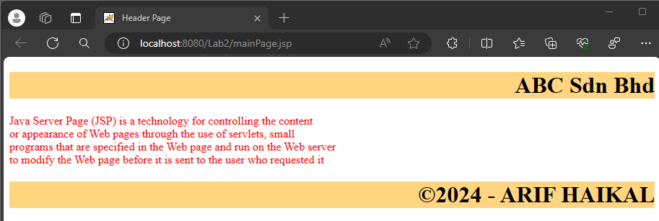

**Reflection**

1. What you have learnt from this exercise?

How to make header and footer using JSP.

1. Write a syntax how you want to include *common.html* file that located at

a directory known as *master.*

<%@ include file="master/common.html" %>

**Exercise**

1. Temperature

TemperatureConvert.jsp

|  |
| --- |
| <%--  Document : TemperatureConvert  Created on : 23 Apr 2024, 11:35:40 am  Author : ARIF HAIKAL  --%>  <%@page contentType="text/html" pageEncoding="UTF-8"%>  <!DOCTYPE html>  <html>  <head>  <meta http-equiv="Content-Type" content="text/html; charset=UTF-8">  <title>Temperature Convert</title>  </head>  <body>  <h2>Temperature Convert</h2>  <form action="<%= request.getContextPath() %>/TemperatureConvert.jsp" method="post">  Enter temperature in Celsius: <input type="number" step="any" name="celsius" required><br>  <input type="submit" value="Convert to Fahrenheit">  </form>  <%  if (request.getMethod().equals("POST")) {  double celsius = Double.parseDouble(request.getParameter("celsius"));  double fahrenheit = (9.0/5.0) * celsius + 32;  %>  <p><%= String.format("Temperature in Fahrenheit: %.2f", fahrenheit) %></p>  <%  }  %>  </body>  </html> |

Output :

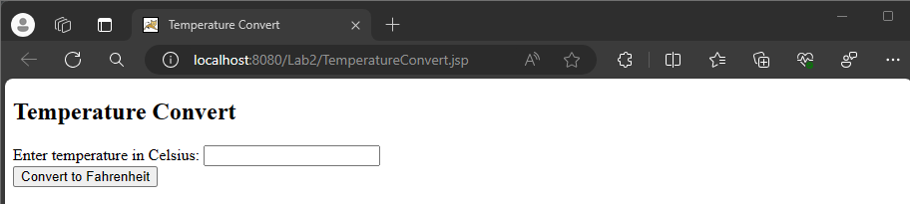

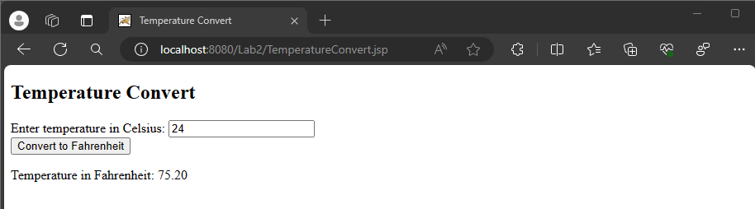

1. Rectangle

Rectangle.jsp

|  |
| --- |
| <%--  Document : Rectangle  Created on : 23 Apr 2024, 11:35:59 am  Author : ARIF HAIKAL  --%>  <%@page contentType="text/html" pageEncoding="UTF-8"%>  <!DOCTYPE html>  <html>  <head>  <meta http-equiv="Content-Type" content="text/html; charset=UTF-8">  <title>Rectangle</title>  </head>  <body>  <h2>Rectangle</h2>  <form action="<%= request.getContextPath() %>/Rectangle.jsp" method="post">  Rectangle 1:<br>  Length: <input type="number" step="any" name="length1" required><br>  Width: <input type="number" step="any" name="width1" required><br>  <br>  Rectangle 2:<br>  Length: <input type="number" step="any" name="length2" required><br>  Width: <input type="number" step="any" name="width2" required><br>  <br>  <input type="submit" value="Compare Areas">  </form>  <%-- Processing form submission and displaying result --%>  <% if (request.getMethod().equals("POST")) {  double length1 = Double.parseDouble(request.getParameter("length1"));  double width1 = Double.parseDouble(request.getParameter("width1"));  double length2 = Double.parseDouble(request.getParameter("length2"));  double width2 = Double.parseDouble(request.getParameter("width2"));  double area1 = length1 * width1;  double area2 = length2 * width2;  String result;  if (area1 > area2) {  result = "Rectangle 1 has a greater area.";  } else if (area1 < area2) {  result = "Rectangle 2 has a greater area.";  } else {  result = "Both rectangles have the same area.";  }  %>  <p><%= result %></p>  <% } %>  </body>  </html> |

Ouput :

